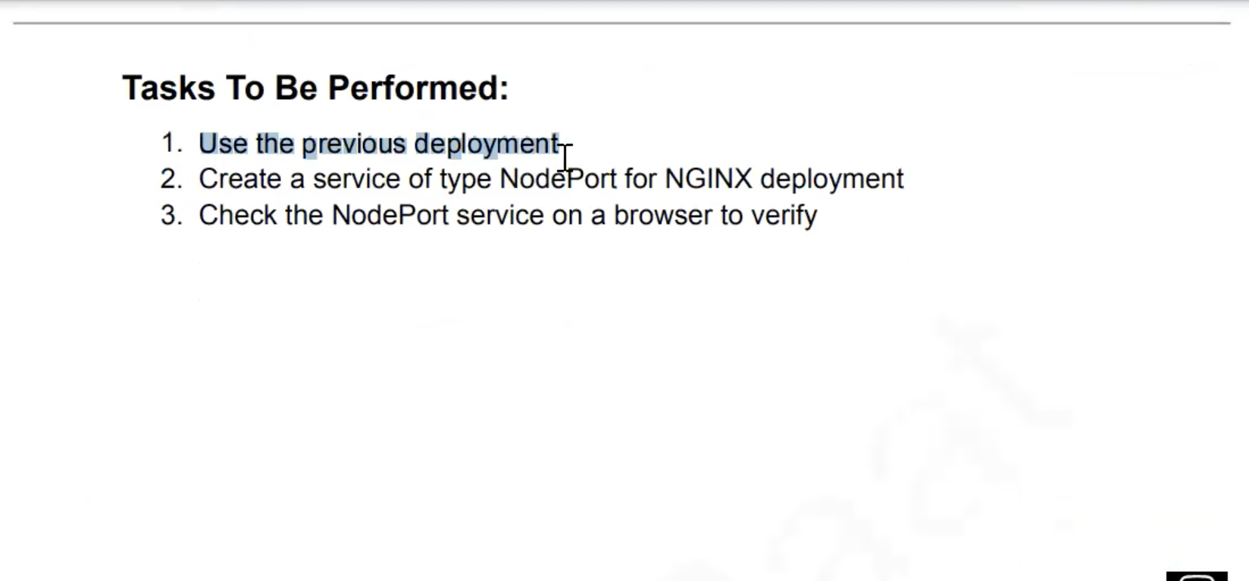

Go to official website of Kubernetes and copy the code for the node port

**apiVersion**: v1

**kind**: Service

**metadata**:

**name**: my-service

**spec**:

**type**: NodePort

**selector**:

**app.kubernetes.io/name**: MyApp

**ports**:

- **port**: 80

*# By default and for convenience, the `targetPort` is set to*

*# the same value as the `port` field.*

**targetPort**: 80

*# Optional field*

*# By default and for convenience, the Kubernetes control plane*

*# will allocate a port from a range (default: 30000-32767)*

**nodePort**: 30008

create the Assignmnet2.yaml

**apiVersion**: v1

**kind**: Service

**metadata**:

**name**: my-service

**spec**:

**type**: NodePort

**selector**:

**app.kubernetes.io/name**: MyApp

**ports**:

- **port**: 80

*# By default and for convenience, the `targetPort` is set to*

*# the same value as the `port` field.*

**targetPort**: 80

*# Optional field*

*# By default and for convenience, the Kubernetes control plane*

*# will allocate a port from a range (default: 30000-32767)*

**nodePort**: 30007

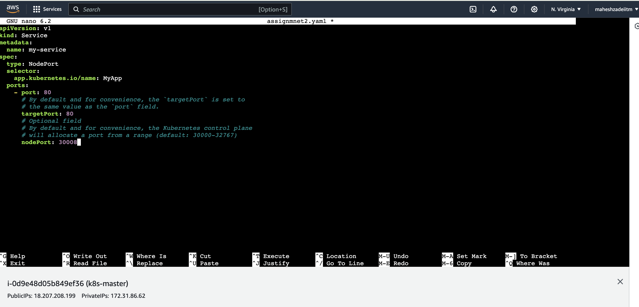

oot@ip-172-31-86-62:/home/ubuntu# ls

assign1.yaml assignmnet2.yaml

root@ip-172-31-86-62:/home/ubuntu# kubectl apply -f assignmnet2.yaml

service/my-service created

root@ip-172-31-86-62:/home/ubuntu# kubectl get svc

NAME TYPE CLUSTER-IP EXTERNAL-IP PORT(S) AGE

kubernetes ClusterIP 10.96.0.1 <none> 443/TCP 140m

my-service NodePort 10.97.24.234 <none> 80:30008/TCP 106s

Change app name to nginx instead of myapp

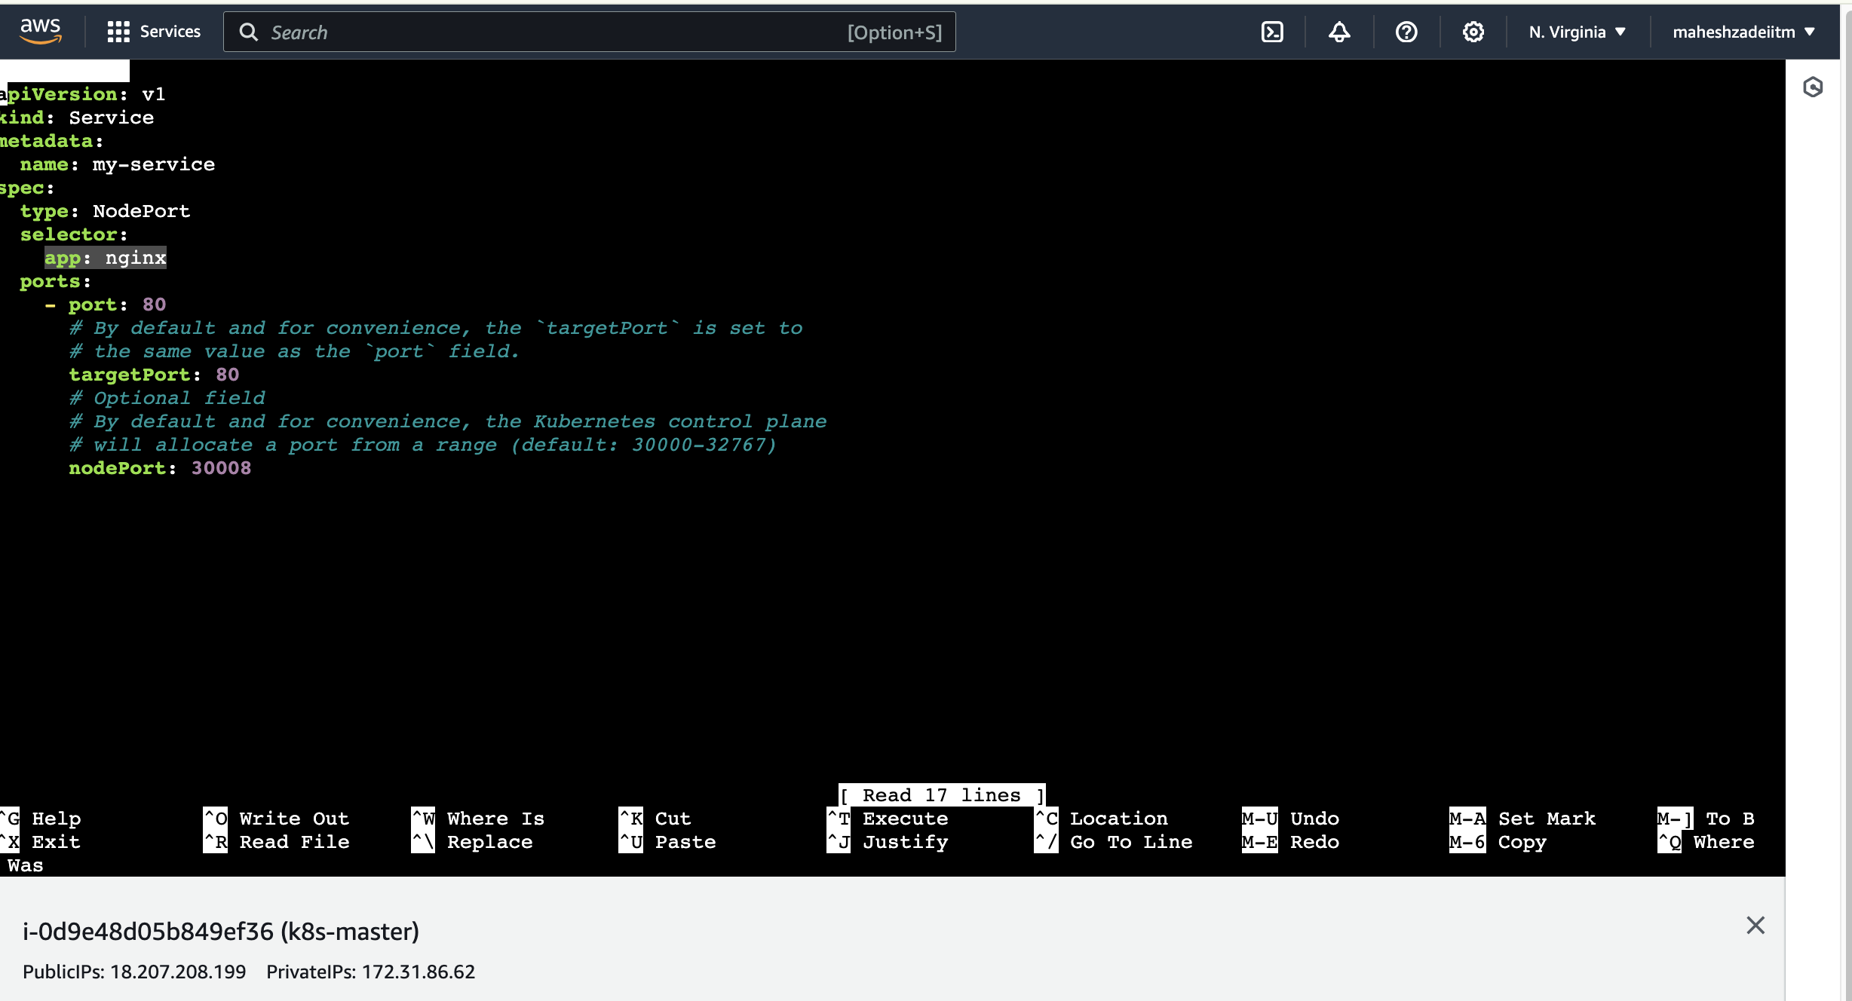

Again run the command

root@ip-172-31-86-62:/home/ubuntu# kubectl apply -f assignmnet2.yaml

service/my-service configured

copy the public IP of the master node and port number 30008 as mentioned in the assgnment2.yaml file

in the browser and nginx app is running or not ‘

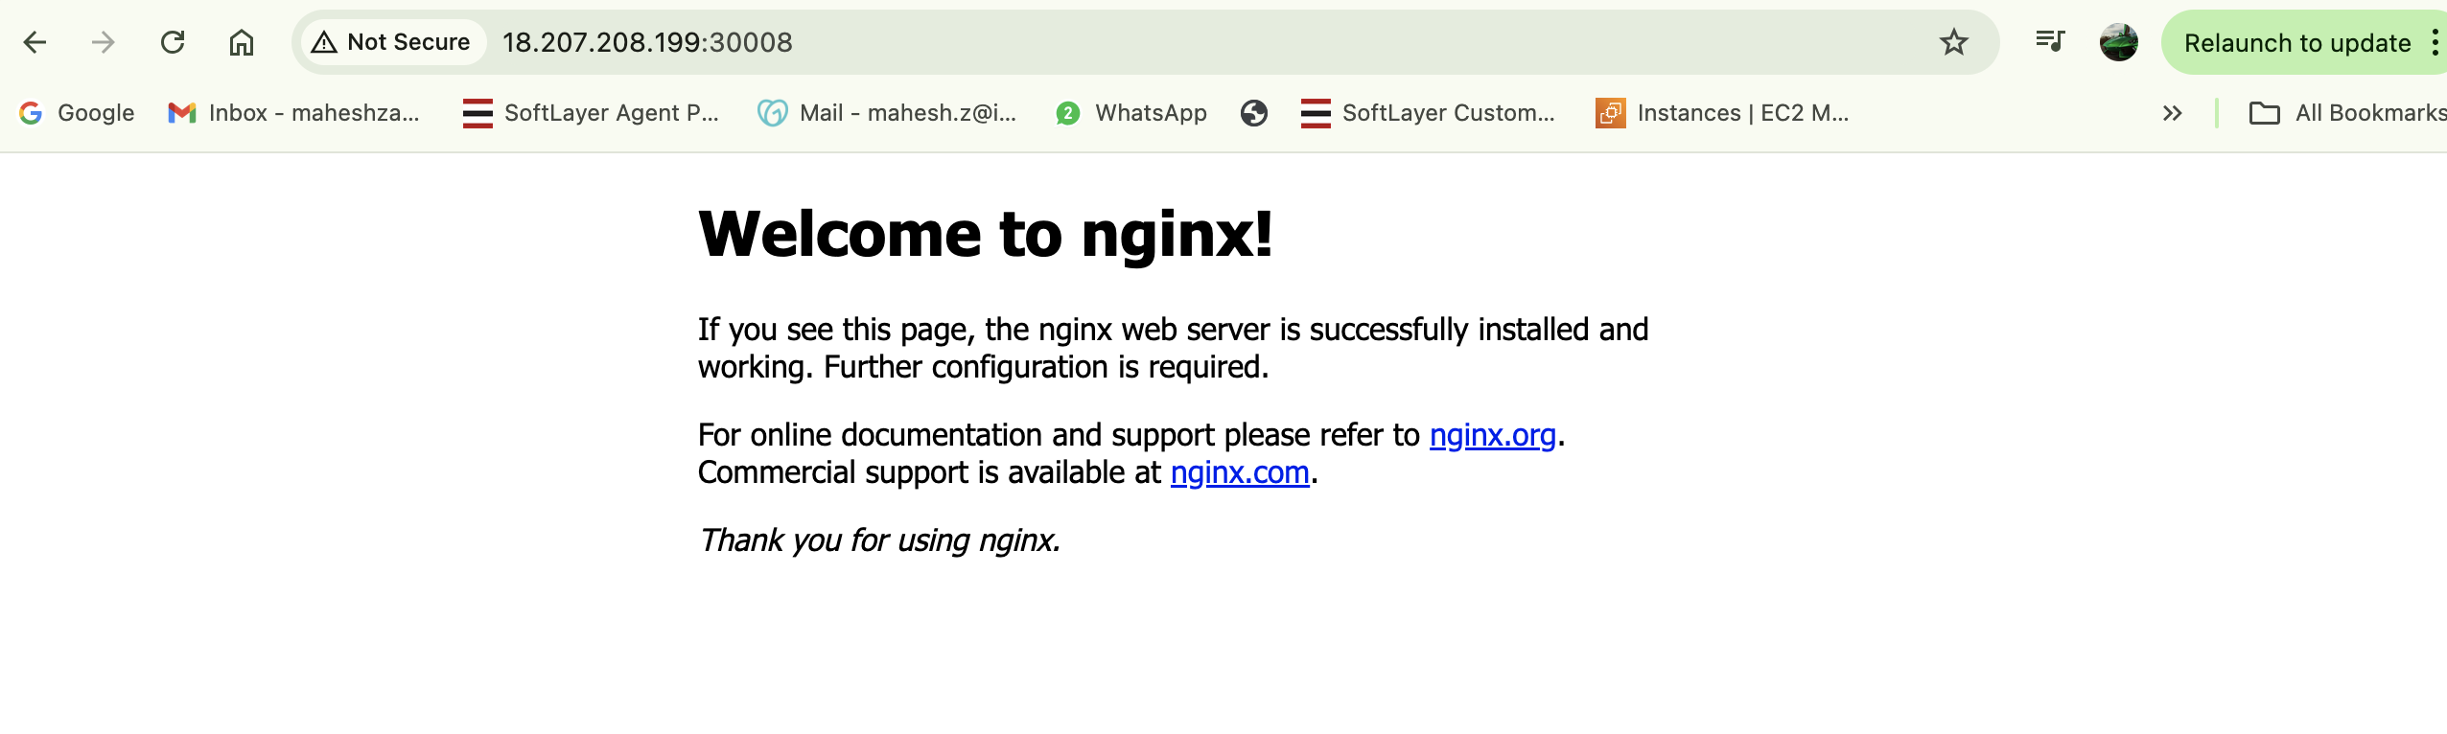

Running successfully .